CURRICULUM VITAE- BEN HAODA

Personal Information
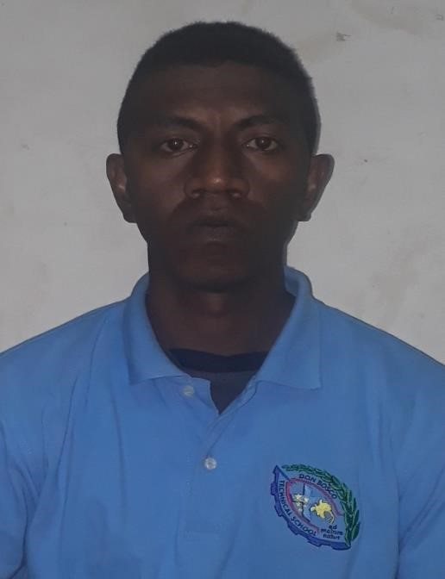 | Name: Ben HAODA  Date of Birth: 6th April 1993  Address: C-/ Sue Maxine Haoda,  P O Box 78,  Port Morseby  NCD  Phone: 7036 5636  7108 8855  78318980  Email:  benjimmysamhaoda@gmail.com  Civil: Single
Motto : “settling for less is never an option, strive for more”

SKILLS &COMPETENCIES
- I am a self though musician who can play various instruments
- I enjoy playing various sports in which helps me socialize well with others in terms of meeting new people
- Teaching is a passion which I love doing and I have theorical knowledge and general practice in primary teaching.
- Mechanical and technical aspect is a hobby since childhood, I enjoy working out in the field with caution and safety measures learning formally and informally.
EDUCATION HISTORY
INSTITUTION | YEAR | ATTAINMENT
Don Bosco Technical  Secondary (Short Term  Course) | 2020 | Certificate House Wiring & Institution
St Benedict Teachers College- Divine Word University | 2O16 - 2017 | Incomplete
Badihagwa Technical Secondary | 2014 - 2015 | Grade 12 certificate
LaSalle Hohola Youth Development Centre | 2012 - 2013 | Grade 10 certificate  Electro Technology Certificate

WORK EXPERIENCE

2021 CURRENT
- Black Swan International
Static Guard at Grand Papua Hotel

Duties: Main guarding and hotel logistics, pickup and drop off for hotel staff

2017
- Coral Sea Hotels- Pacific Privilege
Telephone sale consultant ( Part time job)
Duties : sales of special packages and membership privileges.
Assist clients in bookings and reservations.

2015
- CHM &Sons Ltd
Sales Representative ( Part Time Job )
Duties : Shop assistant
Photo shop assistant

2013
- MJ Electrical Ltd
Trainee Electrician
Duties : basic electrical termination of appliances and electrical general hand.

REFERENCE
- Mr Scott Wilmott
Electrical Instructor
Don Bosco Technical Secondary
Ph: 321 7153

- Mr George Isoaimo
Patrol Care Assistant
Don Bosco Technical Secondary school
Ph: 7108 38386/ 321 7153

- Mr Narol Sapak
Industrial Training Officer
Don Bosco Technical Secondary school
Ph: 7972 2462/ 321 7153

