|  |
| --- |
|  |
|  |
|  |

|  |  |
| --- | --- |
| Curriculum Vitae |  |

**Name: Hoire Kevau (Mr.)**

**Date of Birth:** 31/01/1980

**Sex:** Male

**Nationality:** Papua New Guinean

**Address:**

C/- Mr Kevin Hoire

Spectra Industrial Limited,

PO Box 7528,

Boroko, NCD,

T: +675 323 7181

M: +675 7263 9787

E: [smpom@spectra.com.pg](mailto:smpom@spectra.com.pg)

**Email:** [siiuxlk44@gmail.com](mailto:siiuxlk44@gmail.com)/pngmon03@oilsearch.com

**Mobile:** +675 7936 3306 (Digicel)

**Career objective**

A highly resourceful, flexible, innovative, and enthusiastic individual who possesses a considerable amount of knowledge regarding administrative and office procedures. A quick learner who can absorb new ideas and is experienced in coordinating, planning and organizing a wide range of administrative activities. Well organized and an excellent team player with a proven ability to work proactively in a complex and busy office environment. Hoire is now looking for a career advancement opportunity with a company that will allow him to develop his skills & potential

**PROFESSIONAL STANDARDS**: Strong time management skills with the ability to meet deadlines and perform responsibilities to highest standards without supervision. Ability to adjust to an ever-changing environment.

**TEAMWORK**: Responsive to direction and able to self-manage. Effective communication techniques with ability to work cooperatively with individuals from diverse backgrounds. Highly reactive with experience operating in environments relying on speed, confidence and teamwork. Able to think and act decisively in stressful situations.

**SAFETY**: Trained in OH&S with strong commitment to safety and environmentally conscious work practices. Ongoing active participant in safety meetings, participating in discussions and follow-up action on issues within the Work Place

**Education**

**2007 – 2008** Diploma in Cost Accounting – Due school close down PSTC

Papua New Guinea

**1998 – 1999** Degree in Accounting – Withdrew due to user pay policy I/Correspondence School

USA

**1994 – 1997** Grade Ten Certificate Kupiano High School

Central Province

**1988 – 1993** Grade Six Certificate Wairavanua Primary School

Central Province

**Employment History**

**Feb’2017 – Current Monadelphous Engineering (PNG) Limited, Oil Search Kutubu, Gobe, Moran and Kumul Platform Petroleum Development Projects**

Monadelphous Engineering [PNG] Limited is a multi-million organisation, with Engineering and Plant Maintenance and Pipeline Repairs contracted to Oil Search Limited.

**Position Duties** **QA/QC Administration Officer (Shutdown)**

Assisting the Quality & Welding Co-ordinator in the coordination of quality documentation are supplied, understood, and complied with by the work group. Administers, collates, and coordinates documentation to work teams to ensure that all work is recorded as completed safely, on schedule, to required quality and client specifications.

* Actively monitor work practices and coach employees to ensure adherences to correct procedures and standards for safety and environmental performance.
* Development and ongoing implementation of quality deliverables such as inspection and test plans, field inspection check sheets and welding related documentations.
* Plan and organise work to meet contract time schedule and maximise the efficiency and productivity of the workforce.
* Verification of workshop construction and field activities.
* Preparation and compilation of all project quality verification documentation, mechanical completion documents including the compilation of project MDRs.
* Provide assistance to management, and actively monitor and report employees and contractors with regards to quality compliance requirements, requirement to comply with relevant codes, standards and company procedures.
* Ongoing maintenance & updating assurance documents procedures and sending off the welder qualifications and revalidation NDE reports to be updated into the database register in Perth, Australia.
* Undertake other tasks to support the QA/QC Supervisor and the project and as required.

**Mar’2007 – Oct’2015 Monadelphous Engineering (PNG) Limited, Oil Search Kutubu, Gobe, Moran and Kumul Platform Petroleum Development Projects**

Monadelphous Engineering [PNG] Limited is a multi-million organisation, with Engineering and Plant Maintenance and Pipeline Repairs contracted to Oil Search Limited.

**Position Duties** **Site Administration Officer**

* Daily data entry of hours for employees and forwarding file fortnightly to the Payroll in Brisbane, Australia for processing every Pay Period Endings.
* Management of employees (Nationals and Expatriates) fly-in and fly-out roster with the alignment rosters with flights and crew changes.
* Responsible for handling cash payouts to employees whilst onsite for daily needs.
* Processing Monthly claims from original figures to final invoicing to Oil Search Limited & other Debtors.
* Coordinating & organising office equipment/stationary orders.
* Coordinating filing & general administration duties
* In charge of Logistic, procurement, shipping & freight forwarding.
* Daily, weekly and monthly reporting of hours booked to every work area to management and clients.
* Plant and Equipment Reports to Management and Clients.
* Well-mannered and understands the importance of communicating professionally on behalf of the organization of answering incoming calls, determine purpose of call and transfer calls
* Coordinate pre-employment tests
* Input employee data and maintain employee files
* organize new employee orientations
* Assist with record keeping
* Respond to employee inquiries about human resources issues
* Assist with employee events such as annual leave, sick leave, compassionate leave and other beneficial awards.
* monitor unemployment claims
* liaise with payroll and benefits regarding new employees and changes of employee status
* Relate well to people across all levels regardless of status, ethnicity and gets along well with anyone he works with or meets.
* Completely computer literate in using Microsoft office and other computer programs
* Following standardized company procedures relating to all aspects of Office performance
* Completely computer literate in using Microsoft office and other computer programs
* Taking prompt, decisive and corrective action to rectify and short comings
* Active team member with self-drive and motivation
* Acting with the highest ethical standards and always treating others fairly and with respect

**Jan’2005- Feb’2007 Vetco Aibel [PNG] Limited, Oil Search Limited Kutubu, Gobe, Moran & Kumul Platform Petroleum Development Projects.**

Vetco Aibel [PNG] Limited is a multi-million organisation, with Engineering and Plant Maintenance and Pipeline Repairs contracted to Oil Search Limited.

**Position Duties** **Site Assistant Administrator**

* Daily data entry of hours for employees and forwarding file fortnightly to the Payroll in Brisbane, Australia for processing every Pay Period Endings.
* Management of employees (Nationals and Expatriates) fly-in and fly-out roster with the alignment rosters with flights and crew changes.
* Responsible for handling cash payouts to employees whilst onsite for daily needs.
* Processing Monthly claims from original figures to final invoicing to Oil Search Limited & other Debtors.
* Coordinating & organising office equipment/stationary orders.
* Coordinating filing & general administration duties
* In charge of Logistic, procurement, shipping & freight forwarding.
* Daily, weekly and monthly reporting of hours booked to every work area to management and clients.
* Plant and Equipment Reports to Management and Clients.
* Well-mannered and understands the importance of communicating professionally on behalf of the organization of answering incoming calls, determine purpose of call and transfer calls
* Coordinate pre-employment tests
* Input employee data and maintain employee files
* organize new employee orientations
* Assist with record keeping
* Respond to employee inquiries about human resources issues
* Assist with employee events such as annual leave, sick leave, compassionate leave and other beneficial awards.
* monitor unemployment claims
* liaise with payroll and benefits regarding new employees and changes of employee status
* Relate well to people across all levels regardless of status, ethnicity and gets along well with anyone he works with or meets.
* Completely computer literate in using Microsoft office and other computer programs
* Active team member with self-drive and motivation
* Acting with the highest ethical standards and always treating others fairly and with respect

**Jan’2001 – Sep’2004 Industrial Sales & Services Limited**

**Position Duties Accounts & Admin Assistant**

* Invoicing
* Personal relations skills
* Filing
* Daily Banking
* Followed up on Overdue debtors
* Collected Payments from Customers when ready
* Did Debtors Reconciliation
* Did other General office duties
* Answering incoming & outgoing calls
* Filling, Fax & Photocopying
* Monitoring staffs attendance (Time-in & Time-out)

**Jan’1999 – Dec’2000** **Linking Industries Limited**

**Position Duties** **Accounts & Office Assistant**

* Invoicing
* Daily Banking
* Followed up on Overdue Debtors
* Collected Payments from Customers when ready
* Did Debtors Reconciliation
* Reconciled overdue invoices upon customers request
* Answering incoming calls
* Photo-copying, Binding & Faxing Documents
* Filing
* Does the Monthly Bank Reconciliation
* Coordinating filing and general administration duties
* Answering incoming & outgoing calls
* Filling, Fax & Photocopying
* Monitoring staffs attendance (Time-in & Time-out)

**Other Mandatory Courses**

DuPont STOP (Safety Training Observation Program) Course

Fire Fighting (Safety Training on Fire Fighting) Course

Basic Life Support Course

Stop for Employees Observation course

Job Hazard Analysis course

Various computer training courses (Microsoft Word, Excel, Power Point Presentation, MS Outlook, and Data Base Access)

**Interests**

Business and finance, computers, membership to professional organization, traveling, meeting new people, taking on new challenges, further training and learning, skills development programs, networking opportunities, and others.

**Hobbies**

Like reading, playing rugby, gardening, computers and socializing with people and friends.

**Key Skills and Competencies**

* Developing & implementing new administrative systems.
* Can undertake routine typing and filing duties as appropriate.
* Maintaining effective working relationships with colleagues.
* Strictly following office and company policies and procedures.
* Ability to accurately maintain relevant recording and information systems.
* Able to assist in the recruitment of new staff, sometimes including training and induction.
* Self-motivated with the ability to work on my own initiative.
* PNG Valid Driving License Class 6 (current)

**Referees**

* Mr Dallas Beechey

Site Manager, Monadelphous PNG Limited

Ph: 278 2022

Contact: [pngmon05@oilsearch.com](mailto:pngmon05@oilsearch.com)

* Mr Phillip Jones

Site Manager, Monadelphous PNG Limited

Ph: 278 2022

Contact: [pngmon05@oilsearch.com](mailto:pngmon05@oilsearch.com)

* Mr Thomas Kopits

National Site Supervisor, Monadelphous PNG Limited

Ph: 278 2023

Mobile: 7280 8335

Contact: [pngmon12@oilsearch.com](mailto:pngmon12@oilsearch.com)

Declaration:

I, Hoire Kevau (Mr.), have thoroughly checked the content of my resume to be accurate and have also notified all the above person(s) for their consent to act as my Referee, should you wish to contact them for additional information regarding me.

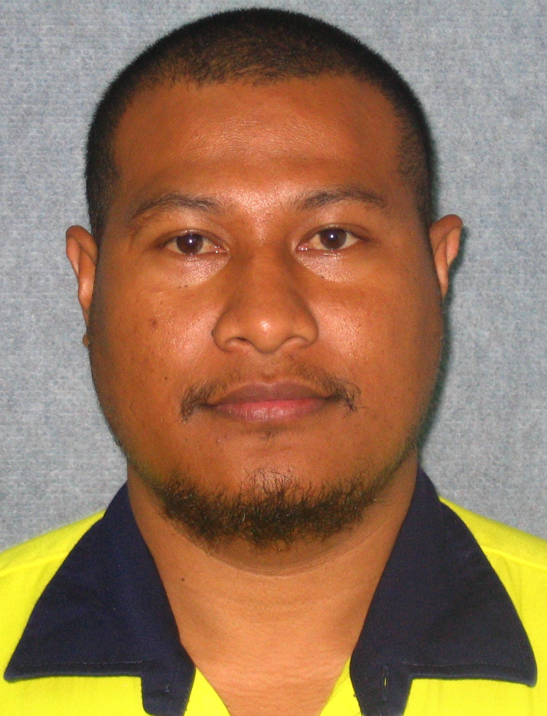

Hoire Kevau (Mr.)