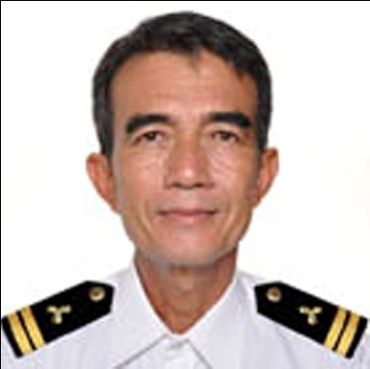GERMAN R. HERNANDEZ JR.

Address: 30 R. Hufano street Lingsat, San Fernando City 2500 Philippines

Nationality: Filipino

Contact Numbers: Mobile +966534158932/ Home +63 072 8883726

Email Address: gerryhernandezjr1961@gmail.com

D.O.B: September 05, 1961

Age: 55 years old

Marital Status: Married

TRADE OR PROFESSION:

**Marine Engineer**

WORK EXPERIENCE

**1. Power Plant Operator**

@SOUTHERN PROVINCE CEMENT COMPANY

AHAD AL MASARHA, JIZAN, K.S.A.

APRIL 28, 2012 UPTO PRESENT

**2.1 Senior Plant Operator**

(10 years; from August 1999 to July 2010)

@BAUANG PRIVATE POWER CORPORATION

225 MW POWERPLANT

**2.2 Generator Operator**

(5 years; from June 1994 to August 1999)

@BAUANG PRIVATE POWER CORPORATION

225 MW POWERPLANT

CERTIFIED

ISO 9001: 2000 (Quality Management System)

 ISO 14001: 2004 (Environment Management System)

 OHSAS 18001: (Occupational Health & Safety Management System)

**3. Officer In Charge of an Engineering** **Watch**

(From August 1986 to May 1994)

**4. Familiar in Sulzer and Wartsila Engines**

**EDUCATION**

1979-1981 TECHNOLOGICAL UNIVERSITY OF THE PHILIPPINES-MANILA

COURSE:

|  |  |
| --- | --- |
| STATIONARY MARINE ENGINEERING  **CERTIFICATES**  1. Certificate of Proficiency (Stationary Marine Engineering) Curriculum 1981  2. Licensed 3rd marine Engineer # E3-0057593 December 1, 2010  3. Certificate of Competency July 2011  4. Certificate (Asea Brown Boveri) Training on Operation and Maintenance July 2004  5. Certificate (Westfalia Separators) Training on Operation and Maintenance February 2004  6. Certificate of Service Record (Bauang Private Power Corporation) June 1994 - July 2010  7. Certification (Marine Engineers Association of the Philippines Inc.) January 2010  8.  Certificate (Basic Safety Training and Instruction) December 2010  9.  Certificate (Medical First Aid) June 2011  10. Certificate (Advance Training in Fire Fighting) June 2011  11. Certificate of Service Record (Various Ocean Going Vessels) August 1986 - May 1994  12. Certification in Control Engineering May 2011  13. Certification in Auxiliary Machinery System June 2011  14. Certification in Engine Room Simulator June 2011 | |
|  |  |  |
|  | |
|  |  |
|  | |
|  | I do hereby certify that the above-mentioned information is true and correct to the best of my knowledge.  Respectfully yours,  German R. Hernandez JR. |
| http://www.myplan.com/images/spacer_1x1.gif | |
|  |  |
| http://www.myplan.com/images/spacer_1x1.gif | |
|  |  |
|  | |
|  |  |
|  | |
|  |  |
|  | |
|  |  |
|  | |
|  |  |
|  | |
|  |  |
|  | |
|  |  |