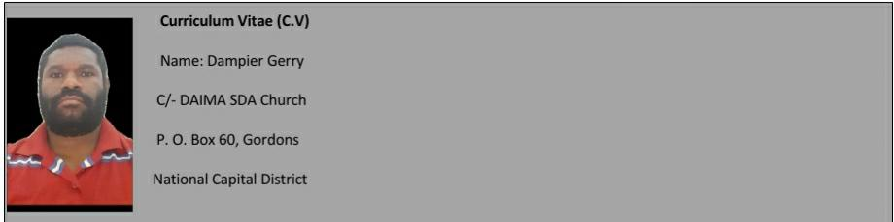

**EDUCATIONAL BACKGROUND**

* 2009 - University of Technology Bachelor of Science in Forestry (BSCF/1)
* 2007 – 2008 Port Moresby National High - Higher School Certificate (Gr:12)
* 2005 – 2006 Kilakila Secondary - High School Certificate (Gr: 10)
* 1999 – 2004 Bavaroko Primary School – Basic Education Certificate (Gr: 8)

**ADDITIONAL STUDIES**

* Practical Skills – Certificate
* Computer Studies – Certificate

**WORK EXPERIENCE**

* Admin assistant - Asamba Investment Ltd Bulolo Morobe Province – 1 year June 2009 – July 2010
* Static Guard - PASS Security Service – 2 years, 2011 – 2012
* Admin Clerk – Gute Security Service Ltd – 2 years, 2013 – 2015
* Accounts/Payroll officer – Gute Security Service Ltd – 1 year, 2015
* Customer Care Agent – Digicel PNG Ltd – 5 years, 2016 – 2020

**HOBBIES**

* Cooking
* Reading
* Sports
* Love exploring new technology

**CONTACT REFEREES**

1. Mr. Gerry Baa – Father _ Ph#: 71790272
2. Kaligen Matthew – Team Leader Digicel PNG _ Ph#: 72223399
3. Elder Sam Teine – Daima SDA Church _ Ph#: 72374784

**DECLARATION**

I Mr Dampier Gerry, has solemnly declare that the information stated above is true and in the best interest of my skills, abilities and experiences.

Signature: ............................................. Date: ................/.........../2021

Mr Dampier Gerry

Interested Applicant