CURRICULUM VITAE

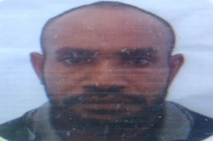**PERSONAL PARTICULARS**

**Name:**  Asron Uku

Date of birth: 13 , of June, 1992

Place of birth : Tabubil Hospital

Sex: Male

Marital status: single

Province: Western

Nationality: Papua new Guinea

Religion: Christianity

Denomination: Community church Network C.C.N

Driver license: class one (1)

Phone number:74373602

Email address: ukuasron@gmail.com

|  |
| --- |
| **EDUCATION ATTAINMENT ( IN ORDER OF MOST RECENT TO PAST)** |
| Year( 2019-2021): Port Moresby Technical college National certificate 1,2 and 3 |
| Year( 2013): Kiunga Secondary school (grade 12) |
| Year (2010): Ningerum high school (grade 10) |

|  |
| --- |
| **EMPLOYMENT RECORD WORK EXPERIENCE** |
| YEAR 2020: OJT On nob training With GFI- (six months) |

**HOBBIES**

Reading, listening to music, playing football, swimming and learning new things.

**REFFERIES**

1. Mr. Waimangu (Principal PMTC) 2. Mr Tatao (H.O.D electrical) 3. Mr Jake Mitiam( deputy

P.o.box 1969 ,NCD P.O.Box. 1969 NCD academy)

Port Moresby . Port Moresby. P.o.box 1969 NCD

Phone#: 75702794 Port Moresby

Phone #:75315436

I sincerely declare that the information provided above is correct and true to the best of my knowledge.

ASRON UKU

(CV holder)