PERSONAL DATA

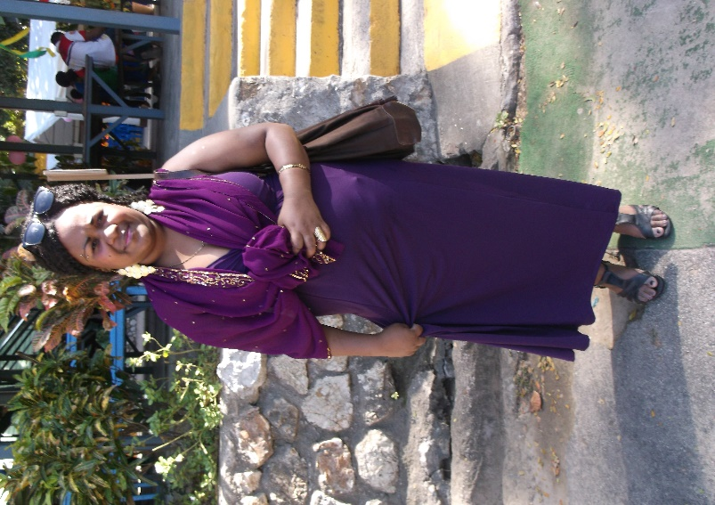
- Name: DEBBIE LUMBIA
- Date of Birth: 04TH April 1988
- Age: 29 yrs.
- Citizen: Papua New Guinea
- Postal Address: C/- PO Box 6544 Boroko, NCD
- Email: debzlumbia@gmail.com
- Cell Phones: 737 95 471/ 75394590
723 69929- (C/- Mr. Cyril Lumbia- Parent)

BIO DATA

- Height: 160cms
- Gender: Female
- Skin Color: Fair
- Village: Tanamalit
- Province: Autonomous Region of Bougainville
- Religion: Pentecostal
- Marital Status: Married
- Children: 1

EDUCATION

- 2017 Sales Representative at
Pacific International Hospital Eye Care Department.

- 2016 IEA College of TAFE (Ela Beach)
(Certificate III in Information, Digital Media & Technology)

- 2011-2012 Limana Community College
(Certificate in Hospitality Management)

- 2011-2012 6 weeks On Job Training at Crowne Plaza Hotel
Front Office Department (Switchboard operator).

- 2006 Industrial Training Course (ITC) Caritas
Technical Secondary School
- 2003-2004 Grade 9-10 Gerehu Secondary School
- 1995-2002 Grade 6-8 Waigani Primary School

LANGUAGE AND DEGREE OF FLUENCY

- Tok-Pisin (Fluent)
- English (Fluent)

REFEREES

(A) Ms. Tracy Wafewa
Head of Department
Information Technology Training Department
PO Box 1025
Port Moresby
NCD
Papua New Guinea
Phone: (+675) 321 30 22
Fax: (+675) 321 04 65
Email: twafewa@tafe.iea.ac.pg

(B) Pastor Joshua Andrew Lanis
Four Square Gospel Church
Port Moresby
NCD
Phone: Digicel (+675) 727 10 286
BMobile (+675) 768 58 553

Oath
I, the undersigned confirm that the information provided here is:
(I) to the best of my knowledge that this CV correctly describes myself, my qualifications and my experiences;
And
(II) Any willful miss-statement in this CV may lead to my dismissal, if engaged in whatever may.

Signature: _____________________ Date: ______ /______ /______
Ms. Debbie: Lumbia

