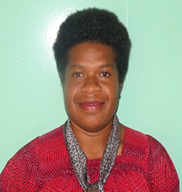

**ELVINA TATO**

PO BOX 09 KAINANTU EHP

PHONE: 79489431/79476104 |E-mail: elvinatato@gmail.com

**Personal Details**

* Date of Birth: 03 November, 1992
* Age: 24
* Gender: Female
* Marital Status: Single
* District: Okapa, Eastern Highlands Province

**Interests**

* Travel and Explore Nature
* Meet New People

**Experience**

* ***Climate Change Project Officer***: April 2016 – March 2017: Eastern Highlands Provincial Administration PO Box 880 GOROKA, EHP.

*Responsibilities*

* Assist in resource development programs
* Provide scientific technical advice and analyze environmental reports
* Organizing climate change activities in EHP
* Working with other colleagues to implement Rice and Mushroom projects in EHP
* Writing Provincial Climate Change Policy (still in progress)
* Assist in Office Administration work (meeting minutes taking, filing, circulating memos, etc...)
* ***On-Job Trainee***: Wildlife Trade and Enforcement Branch- Conservation Environment Protection Authority(CEPA): July 2015- August 2015

*Responsibilities*

* Research on endangered species if aquatic species and developing conservation strategies of their sustainable use.
* Participated and contributed on the Biodiversity Project seminar hosted by CEPA_JICA
* Took part in the Mangrove Rehabilitation in several coastal villages near Port Moresby, PNG.