CURRICULUM VITAE: Gladys Gule
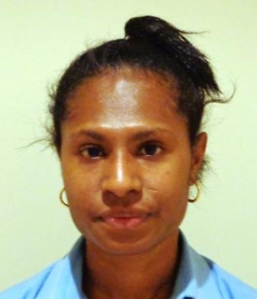
Personal Details
Name: Gladys Gule
Gender: Female
Marital Status: Single
Date of Birth: 18/10/1994 (22years)
Origin: Ma

Contact Details
Postal Address: Gladys Gule
P O Box 276
University of Papua New Guinea
WAIGANI
Phone Number: 7377 9379
Email:gggule94@gmail.com

Career Statement
To be productive Human Resource for this nation, also useful asset to organisation to help others, help them utilise my skills and knowledge. Furthermore I strongly believed to be a person and competitive towards my career.
Employment
Senior Receptionist/Client service officer for City Specialists Medical Centre
Accounts Officer for City Specialists Medical Centre
Education
INTERNATIONAL TRAINING INSTITUTE-2015
Diploma in Accounting –Certificate
Diploma in Accounting-Transcript

PORT MORESBY INSTITUTE OF MATRICULATION STUDIES-2014
Advance Maths Transcript
Applied English Transcript
History of Science & Technology Transcript

MERCY SECONDRY SCHOOL- 2010 - 2013
Grade 12 Certificate
Grade 10 Certificate
Ambition
To be productive Human Resource for this nation, also useful asset to organisation to help others, help them utilise my skills and knowledge. Furthermore I strongly believed to be a person and competitive towards my career.
Skills
MYOB
Computing (Excel, Microsoft word)
Good time management skills
Good interpersonal skills
Hard working
Very responsible, dedicated and committed in team work
Referees
NAME | TITLE | CONTACT DETAILS
Ms. Schola. Pius | Head Of Mathematic Department | Mercy Secondary School  Yarapos  P. O. Box 580  Wewak  East Sepik Province  Phone: 456 2188  Fax: 456 2142  Mobile: 71721822  Bmobile: 76299820  Email: mssypng@gmail.com
Mr Sivanthan Sivaruban | Director  Studies and Distance Education  (letter still in process) | International Training Institute  P. O .Box 6322  Boroko, NCD  Phone:320 2800

