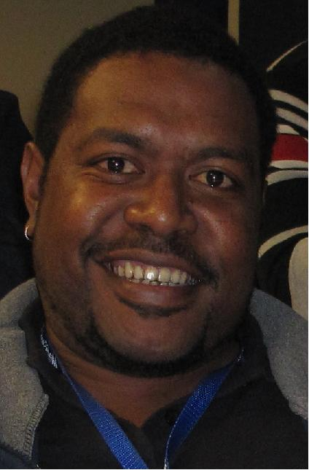

**Jason Maiasa**

Goroka Town : Eastern Highlands Prov. Phone:71887626 e:[jnmaiasa@gmail.com](mailto:jnmaiasa@gmail.com)

**Electro-Technology Specialist**

* Highly Experienced Electrical/Electronic professional with 15 years of experience within service and engineering oriented companies across diverse industries.
* Respected leader of service teams, project teams driving individuals towards exceeding desired outcomes within allocated time. An innovative thinker, providing solutions through technological innovation.
* Expert in the Electrical and Electronic Fields with the key ability to pick up new process and procedures regardless of industry
* As a member of the Papua New Guinea Institute of Engineers I continually strive to excel within the Electro-technology field.

**Skills**

|  |  |
| --- | --- |
| * Project Scoping and Co-ordination * Service & Maintenance Scheduling * Comprehensive Service report writing * Very Strong Trouble shooting skills * Very Strong Electrical/Electronic & Communications Trouble shooting * Very Strong Understanding of sensing principles * Very Strong understanding of machine -machine interfacing and machine - PC interfacing | * Industrial Electrical & Electronic Process control methods including PLC and DCS utilization. * Ability to read Electrical & Instrumentation drawings * Use of Electrical, Electronic & Communications measuring tools * Use of mechanical & industrial electrical tools in service and repair * Running field cable, Electrical, Communications and data. |

**Professional Experience**

**NOJA ELECTRICAL, Murarrie , Brisbane Australia** – *Multimillion-dollar Australian company manufacturing Electrical Switch gear for Electrical Transmission Control/Monitoring and Protection 10 to 38 kV*

**Production Operator SIM Module,** Jun/2016 to Dec/2016

Working in the Electronic Section, assembling/testing and calibrating of Electronic Modules, used in the Assembly of the Main control switchboard.

***Selected Accomplishments:***

* Contributed towards the write up of SWP (standard work procedures)
* Assisted Automation Engineer in the commissioning and testing of the new Automated Test and calibration Unit for Switchgear Interface Module (S.I.M) testing and calibration.
* Trained operators in proper test and calibration process for the S.I.M module
* Continually meeting and exceeding production requirements for S.I.M module

|  |  |
| --- | --- |
| **Jason Maiasa** | Page 2/3 Phone:71887626 |

**Papua new guinea institute of medical research (pngimr), Goroka** – *Medical Research Institute researching prevalent and emerging diseases within PNG*

**Senior Technical Officer,** Jan 2011 to Dec 2015 Ensured that all laboratory equipment’s and underlying Electrical/Electronic Infrastructure for the Institute were maintained always. To also provide PNGIMR senior management Technical support on advisory level.   
  
***Selected Accomplishments:***

* Decreased expenditure on external contractor-general biomedical repairs to K0.00 during tenure
* Conducted a complete Electrical Audit of Headquarters and resultant corrective actions ***Halving Electricity Bill*** from Nov 2012 to date.
* After Electrical Audit, upgraded 30 KVA UPS system to 60 KVA system managing Electrical load sufficiently (Project costs: K250,000.00)
* Lead a service team to repair 20-year-old 150 KVA Generator (repair costs: less than K50,000.00)

**Oktedi Mining ltd, Tabubil** – *PNG’s largest Copper and Gold mine located in western province*

**Process Control Engineer – DCS & SCADA,** Aug 2006 to Oct 2009

Part of a 5-man team responsible for the DCS and SCADA controls utilized within the process control systems of the mine/mill.  
***Selected Accomplishments:***

* Assisted in the Upgrade of reclaim Process controls from Series 6 I/O card control to Ge Fanuc 9070 field I/O control using GE Bus system
* Upgraded Lime Kiln control systems from individual I/O cards in Ge 9070 system to Field I/Os using Ge Bus
* Tested and commissioned Process Control elements during Commissioning of new Sulphur Filtration plant 2009
* Appointed Process Control FIRE warden and lead a project to interface fire alarm panels to Audible Mine Intercom system for audible fire alarms

**Security systems ltd** – *Sister company to Guard Dog Security Ltd. Security Systems is responsible for security electronics, Communications and Marine Electronics.*

**Marine Electronics Technician – Marine Electronics and Communications Dept.,** Oct 2003 to Aug 2006

Part of a 3-man team installing, maintaining, servicing and repairing marine navigational/communications equipment. Also assisting Electronic Security Service team from time to time for major projects in CCTV, Intercoms and Alarms

***Selected Accomplishments:***

* Fully serviced and maintained shipping vessels from Steamships, RH, WTB, and NMSA fleets, including the full installation of navigational aids upon dry dock. Through full tenure
* Complete upgrade and installation of Navigational equipment for PNGDF vessels: HMPNGS SALAMUA , HMPNGS BUNA 2005-2006
* Full installation and commissioning of CCTV for Goodman Fielders Konedobu Mill/office. Including PTZ, and 8 wall mounted cameras spread around plant. Commissioned DVR system as well. 2004
* Maintenance and Service of CCTV systems for MRO, Pacific Place, Credit Corporation, ANZ, Westpac, BSP, GFI and RPYC.

|  |  |
| --- | --- |
| **Jason Maiasa** | Page 3/3 Phone:71887626 |

**Technology**

|  |  |
| --- | --- |
| **Software:** | OPC Conductor, AIMS, RS Logix 500, MS Project, Mozilla Firefox, Photoshop, MS Office (Word, Access, Excel, PowerPoint) |
| **Specialized tools:** | Electrical Safety Analyzer, Process control DMM, Conductor Mega, Oscilloscope, Variable power supplies, Pressure meter, Tachometer, RF power meter. RF Antenna Power meter, Pressure meter. |

**Health & Safety:** Trained Red Cross First Aider (requiring renewal), Experience as Fire warden

**Education and training**

|  |
| --- |
| **Certificate III Electro-technology Electronics and Communications:** *(Queensland’s TAFE),* 2016  **LX200 Service and Maintenance** *(Luminex Auston TX, USA),* 2012  **Magpix Service and Maintenance** *(Luminex Auston TX, USA),* 2012  **Advanced Diploma – Biomedical Equipment Repair** *(Medisend International Global Education Centre Dallas TX, USA),* 2012  **Certificate – Maintaining and Troubleshooting SLC 500 using RS Logix 500 software** *(Rockwell Automation Blackburn, Melbourne),* 2008  **Bachelors of Science in Applied Physics with Electronics & Instrumentation** *(Papua New Guinea University of Technology)* 1998-2002  **Grade 12 Certificate (HSC)** *(Port Moresby National High School),* 1996-97 |

**Professional Memberships**

*Institute of Engineers PNG 2009*

**Referees**

**Mr. John Pise**

Phone: 71920420

Email: [johnpise@gmail.com](mailto:johnpise@gmail.com)

***(Ex-Manager Process Control Dept. Mill. OTML)***

**Mr. Samson Akunaii**

Provincial Administrator – Goroka

Phone: 71293923

Email: [sakunaii2009@gmail.com](mailto:sakunaii2009@gmail.com)

***(Ex- Dep. Director PNGIMR)***

**Mr. Eric Petrus** Manager NAV-AIDS & Investigations

N.M.S.A

Phone: +675 321 1244

Email: [epetrus@nmsa.gov.pg](mailto:epetrus@nmsa.gov.pg)

***(Ex-Manager Communications and Marine Electronics –Security Systems)***