**MINIT EREMAS**

(+675) 73872046, (+675) 71163991

[eremasminit@gmail.com](mailto:eremasminit@gmail.com)

**PERSONAL OBJECTIVE**

To work well under and through with the most experienced employees, so that I can build and developed my skills and knowledge.

Giving my best for the interest, growth and development of the company or organisation.

**EDUCATION**

**International Training Institute (ITI)**

2020

Diploma in Human Resource Management

2019

Certificate in Human Resource Management

**Malabunga Secondary School**

2016

Upper Secondary Certificate

**George Brown High School**

2014

Lower Secondary Certificate

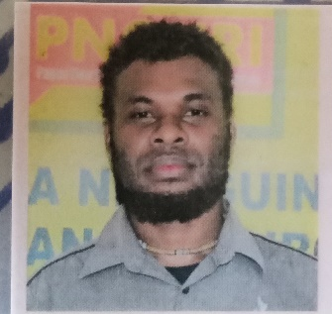

**PASSSIONS**

* Fixing laptop, phones, software programing
* Reading history books
* Watching movies

**SKILLS**

* Organisation
* Solving problems
* Conflict resolution
* Socialising
* Team player