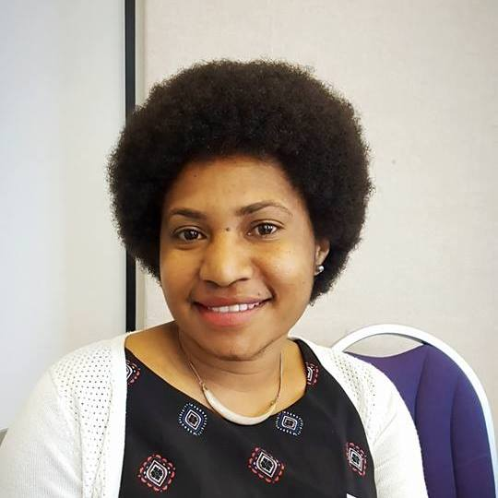Caroline Kiesha Koren (Ms)

**Phone:** (+675 71189308)

**Email:** [carolinekieshak@gmail.com](mailto:carolinekieshak@gmail.com)

**Career goal:**

My career goal is to work in an organization where I can add value through accomplishing challenging tasks and achieving goals, to motivate those around me to learn, adapt and improve their performance in order to become valuable members of the organization. I am personally committed to contribute to the development of Papua New Guinea and its citizens.

**Attributes / Competencies:**

Able to research, analyze and evaluate a variety of subjects and write detailed, comprehensive and understandable reports based on my findings.

Able to effectively assist in the development of business and departmental strategic plans.

Effectively manage myself and others in the performance of the requirements needed to get tasks and job assignments done properly and on time.

Able to effectively organize and follow requirements and timelines to ensure project management goals are attained.

Able to work effectively in a team environment, when required, either as a Team leader or Team member.

Able to communicate effectively both orally and in written skills, I am clear and explicit in my instructions to others and do not hesitate to ask questions when I need information*.*

I am willing to learn, improve my skills and knowledge and adapt to difficult and challenging situations.

**Accomplishments:**

Masters Degree in Business Administration from Central Queensland University, Australia (2016)

Student Mentor at Central Queensland University, Australia (June 2015-November 2016)

Bachelor's Degree in Business Management, majoring in Strategic Management from the University of Papua New Guinea (2011).

Certificate in Project Management from Snowy Mountains Engineering Corporation (International).

As a graduate Trainee in Policy I worked with the department of Public Enterprise, I was part of the team for the development of the SWF for the PNG LNG project.

**Job Duties:**

Over my employment history I’ve had a variety of experience in the following areas:

* Assisting in developing EOIs and Project Proposals
* Meeting with Clients and prospective clients to negotiate contracts and seek new business opportunities
* Organising meetings with various Clients, Landowners and Stakeholders, various Government Departments taking minutes and following up with briefings when required
* Assisting Senior Policy Officers in the formulation of policies relating to SOEs and any other policies initiated by the government
* Monitoring and reviewing the performance of all SOEs against their performance criteria
* Booking Appointments, accommodations, flights / travel and training
* Recruiting, screening and recommending potential applicants for recruitment
* Reviewing and updating employee files, contracts, leave entitlements, training, and any other documentation required.
* Maintaining an office, keeping petty cash up to date and ordering office stationary and supplies, and supervising personnel
* Updating rosters, flights for consultants, arranging accommodation, visas and travel

**Employment History:**

|  |  |
| --- | --- |
| June 2013 – February 2015 | HR & Office Administrator (Deepcore Drilling) |
| Dec. 2012 – Feb. 2013 | Assistant HR Officer (Tawap Kamen Investment) |
| Mar. 2012 – Oct. 2012 | Business Development officer (Snowy Mountains Engineering Cooperation) |
| March 2012-Oct. 2012 | Project 1- Project Coordinator (Port Moresby Power Grid Development Project |
| February 2011-December 2011 | Policy Officer- (Department of Public Enterprises) |

I worked at a variety of jobs while going to University – this helped me develop social interaction skills.

**Education:**

**2015-2016:** Masters of Business Administration, Central Queensland University

2011, Bachelor’s Degree (Business Management), University of Papua New Guinea

2006, Grade 12 Certificate, Wabag Secondary School

**recent awards:**

**Recognition Certificate in Student Mentoring**, **Central Queensland University**-2016

**Awarded the Prestige Australian Aid Scholarship to Study in Australia**-2015

**Attainment Certificate in Cardio-Pulmonary Resuscitation- First Response Australia -**2014

**Certificate in Project Management, Snowy Mountains Engineering Corporation International-** June 2012

**Excellence Award in History -Wabag Secondary School-**2006

**Excellence Awards in English- Secondary School-**2004

**Excellence Awards in English Wabag Primary School-**2002

Referees

Ms. Debbie Lane Case Manager (Queensland Area) AusAid PNG Students

Mobile: +61417258799

Email: [Debbie.Lane@scopeglobal.com](mailto:Debbie.Lane@scopeglobal.com)

Ms. Leonnie Paranda

Project Engineer PNG Power Limited

Phone: (675) 719 24465

Email: (675) [Leonnieparanda@gmail.com](mailto:Leonnieparanda@gmail.com)