**CURRICULMN VITAE (CV)**

Date of Birth: 05/05/1991

Place of Birth: Kimbe General Hospital

Origin: East Sepik province-Maprik

Denomination: Restoration Revival Ministries

Marital Status: Engage

Kimberly Deshry Ambi

Digicel#:70444235/70720931/75870982 or PH: 472 2388

E-mail: electricaladminlae@seetokui.com / kimberlyambi@gmail.com

**Objective**

To further advance my admin career with the valuable job experiences gained over the years'.

To seek a rewarding career and to realize my full potential.

To be an asset to an organization in order to maintain effectiveness, efficiency & productivity.

**Strengths**

• 

Has over 4 years of administrative experience with Seeto Kui Group of companies

• 

Flexible in multi roles from Administration to Accounts to Sales to Retail to warehouse

Operations

**Education**

Diploma in Business Management@ International Training Institute – 2012

Higher School Certificate @ Hoskins Secondary School - 2010

High School Certificate @ Hoskins Secondary School-2008

**Awards**

Dux of ITI in 2012–Diploma Business Management

Seeto Kui Certificate of Attendance 2013-Basic Supervisory Development Course.

**Positions Held**

2013-2017-

Seeto Kui Holdings Limited–Administration Assistant-Administration supervisor.

**Aspirations**

To attain degree in Business Management.

To be an asset in an organization.

To become an Executive Manager in a major organization.

**Referees:**

Patrick Frugal

Seeto Kui Holdings Limited –Operational Admin Manager (Current).

C/Seeto Kui Holdings,-Private Mailbag

PH: 472 2388/479 1111 E-mail: patrickfrugal@seetokui.com

Danilo Camu

Seeto Kui Holdings Limited–Retail Administration Manger.

PH: 4733870/479 1111 E-mail: danilocamu@seetokui.com

.

Pastor Sesere Kebei

Senior Pastor @ Restoration Revival Ministries.

P.O.Box 4499, Lae Morobe Province.

PH: (675) 71198876

Email: restoration.revival.ministries@gmail.com

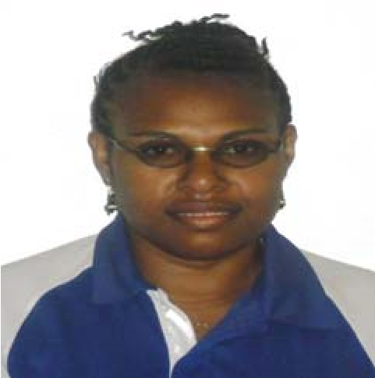

**Fields of Interest**

**BUSINESS, ENTREPRENEURSHIP, GOVERNMENT, ARTS & CULTURE, ETC.**

**Professional Organizations**

**ANY**

**Languages**

**ENGLISH, TOKPISIN & MOTHER TOUNGE**

**Accreditation**

# **NIL**

**Interests and Activities**

**READING, TRAVELING, VOLUNTEER WORK, COOKING, SPORTS, CHILDCARE, MUSIC & CLUB MEMBERSHIPS.**

**Hobbies**

**SPORTS, MUSIC, SOCIALIZING, PAINTINGS, DANCING, GARDENING, ANIMAL CARE, ETC.**

**Volunteer Experience**

**CHURCH VOLUNTEER IN ALL DEPARTMENT OF CHURCH.**

**Computer Skills**

**MS WORD, MS EXCEL, OUTLOOK, POWERPOINT,**

**Licenses and Certificates**

# **NIL**